Framework

🌟 Definition
# Source: AI Source: Provided by: [Data Path: Persons Table -> ID Column: 1, Name_En Column: Motasem Essam] -> From: [ChatGPT] on [6/7/2026]
A Framework is a pre-built structure that provides the foundation, architecture, and rules for developing software applications.
It contains reusable code, tools, libraries, and predefined workflows that help developers build applications faster and in a standardized way.

🎯 Simple Definition
# Source: AI Source: Provided by: [Data Path: Persons Table -> ID Column: 1, Name_En Column: Motasem Essam] -> From: [ChatGPT] on [6/7/2026]
Framework = A Ready-Made Structure for Building Applications
Instead of starting from an empty project, developers build on top of the framework.

🧠 Real-World Analogy
# Source: AI Source: Provided by: [Data Path: Persons Table -> ID Column: 1, Name_En Column: Motasem Essam] -> From: [ChatGPT] on [6/7/2026]
Imagine building a house.
Without a Framework
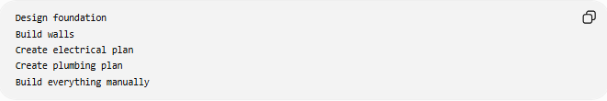
Design foundation
Build walls
Create electrical plan
Create plumbing plan
Build everything manually

With a Framework
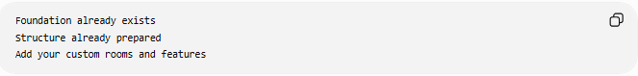
Foundation already exists
Structure already prepared
Add your custom rooms and features
The framework provides the structure; you add the business logic.

🔄 How a Framework Works
# Source: AI Source: Provided by: [Data Path: Persons Table -> ID Column: 1, Name_En Column: Motasem Essam] -> From: [ChatGPT] on [6/7/2026]
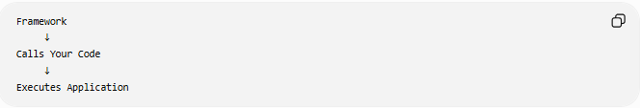
Framework
↓
Calls Your Code
↓
Executes Application
This is known as Inversion of Control (IoC).
Unlike a library, the framework controls the application's flow.

📚 Example
Laravel Route
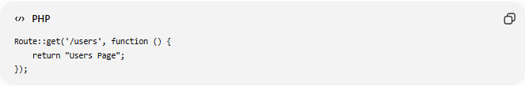
Route::get('/users', function () {
return "Users Page";
});
You write only the route logic.
The framework handles:
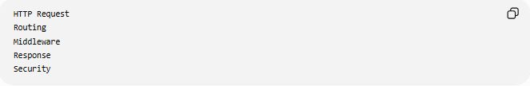
HTTP Request
Routing
Middleware
Response
Security

🧩 What Does a Framework Provide?
# Source: AI Source: Provided by: [Data Path: Persons Table -> ID Column: 1, Name_En Column: Motasem Essam] -> From: [ChatGPT] on [6/7/2026]
A framework usually includes:
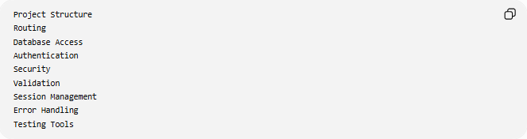
Project Structure
Routing
Database Access
Authentication
Security
Validation
Session Management
Error Handling
Testing Tools

📂 Types of Frameworks

1️⃣ Web Frameworks
# Source: AI Source: Provided by: [Data Path: Persons Table -> ID Column: 1, Name_En Column: Motasem Essam] -> From: [ChatGPT] on [6/7/2026]
Used to build websites and web applications.
Examples:
- Laravel
- Django
- ASP.NET Core

2️⃣ Frontend Frameworks
# Source: AI Source: Provided by: [Data Path: Persons Table -> ID Column: 1, Name_En Column: Motasem Essam] -> From: [ChatGPT] on [6/7/2026]
Used to build user interfaces.
Examples:
- Angular
- Vue.js

3️⃣ Mobile Frameworks
# Source: AI Source: Provided by: [Data Path: Persons Table -> ID Column: 1, Name_En Column: Motasem Essam] -> From: [ChatGPT] on [6/7/2026]
Used to build mobile applications.
Examples:
- Flutter
- React Native

4️⃣ Testing Frameworks
# Source: AI Source: Provided by: [Data Path: Persons Table -> ID Column: 1, Name_En Column: Motasem Essam] -> From: [ChatGPT] on [6/7/2026]
Used to automate software testing.
Examples:
- JUnit
- PyTest

🌍 Real-World Example
# Source: AI Source: Provided by: [Data Path: Persons Table -> ID Column: 1, Name_En Column: Motasem Essam] -> From: [ChatGPT] on [6/7/2026]
Building an Online Store
Without a framework:
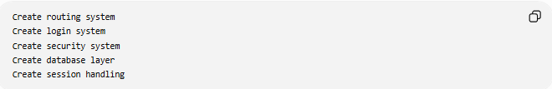
Create routing system
Create login system
Create security system
Create database layer
Create session handling

With Laravel:
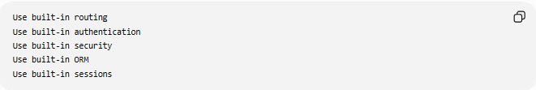
Use built-in routing
Use built-in authentication
Use built-in security
Use built-in ORM
Use built-in sessions
Much faster development.

📊 Framework vs Library
# Source: AI Source: Provided by: [Data Path: Persons Table -> ID Column: 1, Name_En Column: Motasem Essam] -> From: [ChatGPT] on [6/7/2026]
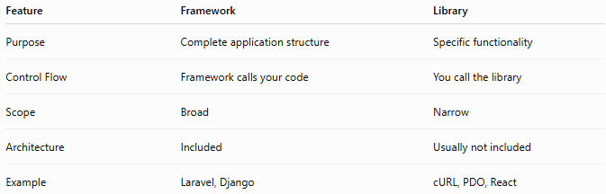
Feature | Framework | Library
Purpose | Complete application structure | Specific functionality
Control Flow | Framework calls your code | You call the library
Scope | Broad | Narrow
Architecture | Included | Usually not included
Example | Laravel, Django | cURL, PDO, React

Library
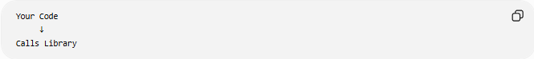
Your Code
↓
Calls Library
Example:
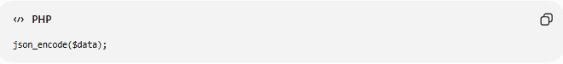
json_encode($data);

Framework
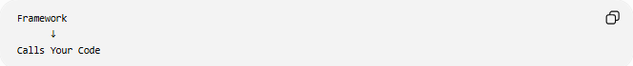
Framework
↓
Calls Your Code
Example:
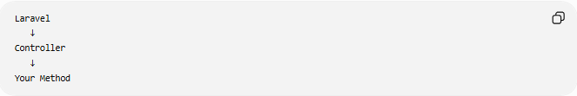
Laravel
↓
Controller
↓
Your Method

📊 Framework vs Library vs Code
# Source: AI Source: Provided by: [Data Path: Persons Table -> ID Column: 1, Name_En Column: Motasem Essam] -> From: [ChatGPT] on [6/7/2026]
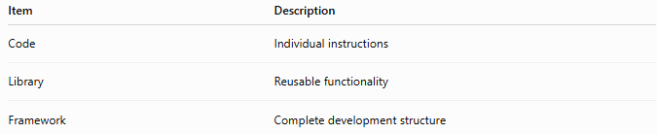
Item | Description
Code | Individual instructions
Library | Reusable functionality
Framework | Complete development structure

Relationship
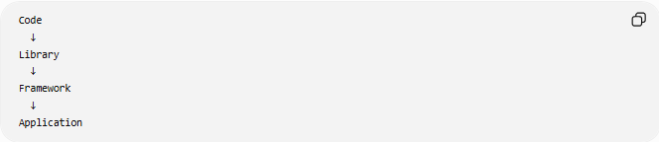
Code
↓
Library
↓
Framework
↓
Application

🛠️ Popular Frameworks
# Source: AI Source: Provided by: [Data Path: Persons Table -> ID Column: 1, Name_En Column: Motasem Essam] -> From: [ChatGPT] on [6/7/2026]
PHP
- Laravel
- Symfony

Python
- Django
- Flask

JavaScript
- Angular
- Next.js

C#
- ASP.NET Core

Mobile
- Flutter
- React Native

✅ Advantages of Frameworks
# Source: AI Source: Provided by: [Data Path: Persons Table -> ID Column: 1, Name_En Column: Motasem Essam] -> From: [ChatGPT] on [6/7/2026]
- Faster development
- Standardized architecture
- Built-in security features
- Easier maintenance
- Reusable components
- Large community support

❌ Disadvantages of Frameworks
# Source: AI Source: Provided by: [Data Path: Persons Table -> ID Column: 1, Name_En Column: Motasem Essam] -> From: [ChatGPT] on [6/7/2026]
- Learning curve
- Less flexibility
- Larger project size
- Dependency on framework updates
- May include unnecessary features

🧠 Simple Analogy
# Source: AI Source: Provided by: [Data Path: Persons Table -> ID Column: 1, Name_En Column: Motasem Essam] -> From: [ChatGPT] on [6/7/2026]
Think of building with LEGO.
Library
A box of LEGO pieces
You decide how to use them.

Framework
A LEGO building kit with instructions
The structure already exists; you follow the framework's design.

🧭 Summary
# Source: AI Source: Provided by: [Data Path: Persons Table -> ID Column: 1, Name_En Column: Motasem Essam] -> From: [ChatGPT] on [6/7/2026]
A Framework is a pre-built software structure that provides architecture, tools, and rules for developing applications. It helps developers build software faster by supplying features such as routing, security, database access, authentication, and project organization. Unlike a library, where your code calls the library, a framework controls the application's flow and calls your code when needed. Frameworks are widely used for web, mobile, desktop, and enterprise application development.

